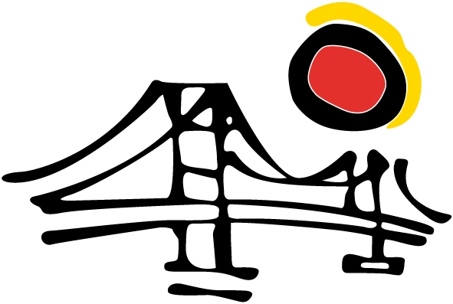
Preparation of CV's &
Job Interviews

What we offer
● We help you design your curriculum with a professional format, wording, and content
● We provide you with the necessary tools to prepare you for the job interview: body language, effective communication (being articulate, turning red flags into strengths, handling objections), etc.
● We prepare you for interviews in English, Spanish, German, Portuguese, and French
● Our experience allows us to ensure that you will at least make it to the short list
Why?
● There is only one good first impression: Learn to be convincing as there will be no second chance
● A thorough curriculum and an effective interview can change your professional life
● Our consultants have interviewed thousands of candidates and they know exactly what an interviewer expects, either in 5 to 10 minute interviews, or in interviews of over 2 hours
● Learn how to sell yourself and turn your weaknesses into strengths

